



HOSPITAL PATIENTS RECORDS CLEANING AND
HEALTH METRICS DASHBOARD

Project Domain
Excel & AI chatbot & Power BI

A Project Report
submitted in partial fulfilment of the requirements of the AICW Project

by:

Student Name
R.JEEVITHA

Student Email
Jeevi3607@gmail.com
Guide
MRS.UMAMAHESWARI

Institution:
Vel Tech Rangarajan Dr. Sagunthala R&D institute of Science and Technology

Year - 2026
ACKNOWLEDGEMENT

We would like to express our sincere gratitude to all those who have supported and guided us throughout the completion of this project.
Firstly, we would like to thank our project guide, MS.Umamaheswari & MS.Jyothi , for their valuable guidance, continuous encouragement, and constructive feedback. Their support and mentorship played a vital role in shaping our ideas and successfully completing this project. The confidence and motivation provided by them greatly contributed to our learning experience.
We would also like to extend our heartfelt thanks to Edunet Foundation, Microsoft, LinkedIn, and SAP for offering this fellowship opportunity. The resources, training, and platform provided by them helped us enhance our knowledge and practical skills in data analytics and AI.
We are grateful to our institution, Vel Tech Rangarajan Dr. Sagunthala R&D Institute of Science and Technology for providing the necessary infrastructure and academic support required to carry out this project successfully. Finally I have express my heartfelt thanks to the opportunity of this fellowship for the guidance support and motivation throughout the project.

ABSTRACT OF THE PROJECT

This project is part of the AICW (Artificial Intelligence in the Contemporary World) Fellowship Program, a collaborative initiative by Edunet Foundation in partnership with Microsoft, LinkedIn, and SAP. The fellowship is designed to equip students with practical, hands-on skills in Artificial Intelligence, Data Analytics, and Business Intelligence tools.

- In the modern healthcare environment, large volumes of patient data are generated daily, making it essential to analyze and interpret this data effectively for better decision-making. This project focuses on the analysis and visualization of a structured healthcare dataset containing key patient-related attributes such as Patient ID, Age, Gender, Disease Type, Treatment Cost, and Treatment Outcome.

- Initially, the dataset was unclean and contained several inconsistencies, including missing values, duplicate records, and formatting errors. Such issues can significantly impact the accuracy and reliability of data analysis. To overcome these challenges, a comprehensive data preprocessing process was carried out using Microsoft Excel. This involved removing duplicate entries, handling missing values using appropriate techniques, and standardizing data formats to ensure consistency and accuracy.

- After the data cleaning phase, the refined dataset was imported into Power BI, a powerful business intelligence tool used for data visualization. An interactive and dynamic dashboard was developed to represent the data in a clear and visually appealing manner. The dashboard incorporates various visual elements such as bar charts, pie charts, line graphs, and KPI indicators, along with filters and slicers to enhance user interaction and data exploration.

- The dashboard provides valuable insights into multiple aspects of healthcare data, including patient demographics (age and gender distribution), disease prevalence, treatment cost analysis, and patient recovery outcomes. These insights help in identifying trends, patterns, and correlations within the dataset, enabling healthcare professionals and administrators to make informed and data-driven decisions.

- Furthermore, the project highlights the importance of data analytics in improving hospital management by optimizing resource allocation, reducing operational inefficiencies, and enhancing the quality of patient care. By transforming raw data into actionable insights, this project demonstrates the practical application of Excel and Power BI in solving real-world healthcare problems.

- In conclusion, this project showcases how effective data cleaning, analysis, and visualization techniques can convert complex healthcare data into meaningful information that supports strategic planning and decision-making in the healthcare sector

TABLE OF CONTENTS

Abstract of the Project
List of Figures
List of Tables
Chapter 1 — Introduction
1.1 Problem Statement
1.2 Motivation
1.3 Objectives
1.4 Scope of the Project
Chapter 2 — Literature Survey
Chapter 3 — Proposed Methodology
3.1 System Design
3.2 Modules / Components Used
3.3 Data Flow Diagram (DFD)
3.4 Advantages
3.5 Requirement Specification
Chapter 4 — Implementation and Results
4.1 Data Cleaning Results
4.2 Visualization / Output Results
4.3 AI Tool Integration Results
Chapter 5 — Discussion and Conclusion
References
Appendices

LIST OF FIGURES

Figure No. | Figure Title / Description | Page No.
Figure 1 | [Raw / uncleaned dataset screenshot] | 21
Figure 2 | [Cleaned dataset or validation summary screenshot] | 22
Figure 3 | [Main dashboard / report / output screenshot] | 22
Figure 6 | [DFD Level 0 — Context Diagram] | 17
Figure 7 | [DFD Level 1 — Detailed Process Flow] | 18

LIST OF TABLES

Table No. | Table Title / Description | Page No.
Table 1 | [Raw dataset summary — field names, data types, row count] | 31
Table 2 | [Cleaned dataset summary — issues found and fixed] | 32
Table 3 | [Hardware Requirements] | 19
Table 4 | [Software Requirements] | 20
Table 5 | [Key findings / results summary] | 28

CHAPTER 1
Introduction
This chapter introduces the project undertaken as part of the AICW Fellowship Program. It outlines the background, the problem being addressed, the motivation behind this work, and the objectives and scope of the project. The fellowship projects span multiple domains including Data Analytics, Business Intelligence, Healthcare Analytics, Content Generation, and AI-assisted Reporting.
1.1 Problem Statement
My project core problem are :
- In the healthcare sector, vast amounts of patient data are generated continuously through clinical activities, diagnostic procedures, and administrative processes. Although this data holds significant value for improving patient care and operational efficiency, it often remains underutilized due to poor data quality and lack of proper analytical frameworks.

- The dataset used in this project reflects common real-world data challenges that hinder effective analysis. One of the major issues is data incompleteness, where essential attributes such as patient age, gender, or treatment details are missing. This lack of complete information can lead to biased analysis and unreliable conclusions.

- Another critical concern is data redundancy, caused by duplicate patient records. These duplicates distort the actual representation of patient counts and treatment outcomes, leading to misleading insights and affecting decision-making processes.

- Additionally, the dataset exhibits data inconsistency, particularly in the representation of disease names and categorical fields. Variations in spelling, formatting, and naming conventions prevent proper classification and aggregation of data, making comparative analysis difficult.

- Moreover, the absence of structured organization and visualization mechanisms makes it challenging to extract meaningful insights from the dataset. Without proper tools, identifying trends such as disease prevalence, cost variations, and recovery patterns becomes complex and time-consuming. As a result, healthcare professionals may struggle to interpret the data effectively and make timely, informed decisions.

- These challenges highlight a critical gap between raw data availability and actionable insight generation in healthcare systems. Poor data quality and lack of visualization not only reduce analytical efficiency but also impact strategic planning, resource allocation, and overall quality of patient care.

- Therefore, there is a strong need for a systematic approach that involves data cleaning, transformation, and visualization. By leveraging tools such as Microsoft Excel for preprocessing and Microsoft Power BI for dashboard development, the dataset can be converted into a structured and interactive format. This enables the identification of key patterns, trends, and performance indicators, ultimately supporting data-driven decision-making in healthcare management.
1.2 Motivation
- The motivation behind selecting this project stems from the increasing importance of data analytics in the healthcare sector. In today’s digital age, healthcare institutions generate vast amounts of data through patient records, diagnostic systems, and treatment processes. However, much of this data remains underutilized due to lack of proper analysis and visualization. This project was chosen to bridge the gap between raw healthcare data and meaningful decision-making.

- From a personal perspective, this project is highly meaningful as it provides an opportunity to apply data analytics concepts to a real-world domain that directly impacts human lives. Working with healthcare data enhances understanding of how analytical tools can be used not only for business purposes but also for improving societal well-being. It also helps in developing practical skills in data cleaning, analysis, and visualization using tools like Microsoft Excel and Microsoft Power BI, which are widely used in the industry.

- From a professional standpoint, this project aligns with the growing demand for data-driven decision-making across industries. Organizations today rely heavily on business intelligence tools to interpret large datasets and extract actionable insights. By working on this project, it becomes possible to gain hands-on experience in transforming raw data into structured information and presenting it through interactive dashboards, which is a valuable skill in fields such as data analytics, business intelligence, and healthcare management.

- The real-world applications of this project are significant. The developed dashboard can be used by hospitals and healthcare administrators to monitor patient demographics, analyze disease trends, evaluate treatment costs, and assess recovery outcomes. This can help in improving resource allocation, optimizing treatment strategies, and enhancing overall operational efficiency. Additionally, it can support early identification of common diseases and cost-intensive treatments, enabling better planning and management.

- The potential impact of this project on the healthcare domain is substantial. By providing clear and visual insights, the project can assist decision-makers in making informed choices that improve patient care and reduce inefficiencies. It also contributes to better data management practices, ensuring that healthcare data is accurate, consistent, and useful.

- Furthermore, this project strongly aligns with modern industry trends in Artificial Intelligence (AI) and data analytics. Today, organizations are increasingly adopting data analytics and visualization tools to gain competitive advantages. The integration of data preprocessing and visualization techniques demonstrated in this project reflects current industry practices, where data-driven insights play a key role in strategic decision-making.

1.3 Objectives
- To collect and analyze the structure of the healthcare dataset.

- To identify key variables such as Patient ID, Age, Gender, Disease Type, Treatment Cost, and Treatment Outcome, and to examine data types, relationships, and completeness.

- To clean and preprocess the dataset to improve data quality.

- To remove 100% duplicate records, handle missing values using appropriate methods, and standardize data formats using Microsoft Excel to ensure consistency and accuracy.

- To perform domain-specific analysis on healthcare data.

- To analyze patient demographics, disease distribution, treatment costs, and outcomes using tools such as Microsoft Excel and Microsoft Power BI.

- To design and develop an interactive dashboard.

- To build a Power BI dashboard with visual elements such as charts, graphs, and KPIs, enabling users to explore insights through filters and slicers.

- To utilize AI tools to enhance analysis and reporting

- To leverage AI tools like Microsoft Copilot or chatbot technologies to automate data interpretation, generate summaries, and improve reporting efficiency.
- To generate actionable insights for healthcare decision-making.

- To identify trends and patterns in patient data and provide insights that support better decision-making in areas such as treatment planning, cost management, and resource allocation.

  - Scope of the Project

- This project is based on a structured healthcare dataset consisting of patient records, including attributes such as Patient ID, Age, Gender, Disease Type, Treatment Cost, and Treatment Outcome. The analysis is limited to this dataset and focuses only on the information available within it.
- The project is limited to the use of Microsoft Excel for data cleaning and preprocessing, and Microsoft Power BI for data visualization and dashboard development. Additionally, AI tools such as Microsoft Copilot or chatbot technologies may be used to assist in analysis and report generation.
- The project primarily focuses on data preprocessing, exploratory data analysis, and visualization. Key areas of analysis include patient demographics, disease distribution, treatment cost evaluation, and treatment outcome analysis. The emphasis is on transforming raw data into meaningful insights through visual representation.

- The project includes the development of an interactive dashboard that allows users to explore data through charts, graphs, and key performance indicators (KPIs). The dashboard is designed for analytical and presentation purposes rather than real-time operational use.

- This project does not include advanced functionalities such as real-time data integration, predictive modeling, machine learning algorithms, or automated decision systems. It also does not involve handling live hospital databases or sensitive patient information beyond the provided dataset.
- This project is developed as part of an academic/fellowship requirement to demonstrate practical knowledge of data analytics and visualization tools. It is intended as a prototype or demonstration model and not as a fully deployed, production-level healthcare system.

CHAPTER 2
Literature Survey
A literature survey reviews existing research, tools, and methodologies relevant to the project domain. It helps identify gaps that the current project aims to address.
2.1 Existing Work and Research

- Several studies highlight the role of data analytics and business intelligence tools in improving healthcare outcomes. Research on healthcare analytics using Power BI demonstrates that visualization tools can effectively analyze patient data and support better decision-making in areas such as cost reduction, diagnosis, and patient management . Similarly, studies on big data analytics in healthcare emphasize the use of descriptive and predictive analytics techniques to identify patterns, improve treatment strategies, and enhance patient care .

- Data cleaning has also been identified as a critical step in healthcare analytics. Research shows that a significant portion of data analysis time is spent on cleaning tasks such as handling missing values, removing duplicates, and correcting inconsistencies .

- Frameworks have been proposed to standardize data cleaning processes, especially for electronic health records, ensuring better data quality and reliability for analysis .

- In addition, business intelligence dashboards have become an essential tool in healthcare systems. BI dashboards provide real-time access to key performance indicators (KPIs) and summarized data, enabling healthcare administrators to monitor performance and make informed decisions efficiently .

2.2 Tools and Technologies Review
Briefly review the tools and technologies used in your project:
Microsoft Excel -Microsoft Excel is one of the most widely used tools for data preprocessing and analysis. In this project, Excel is primarily used for cleaning and transforming the raw healthcare dataset. It provides a range of functionalities that support data preparation, including:

  - Removal of duplicate records to ensure data accuracy
  - Handling missing values using statistical or logical methods
  - Data validation to maintain consistency and correctness.Use of Pivot Tables for summarizing large datasets
- Application of conditional formatting to highlight patterns and anomalies
- Excel serves as a foundational tool in this project by ensuring that the dataset is clean, structured, and ready for further analysis.
- Microsoft Power BI
- Microsoft Power BI is a powerful business analytics and data visualization platform used to create interactive dashboards and reports. In this project, Power BI is used to transform processed data into meaningful visual insights.
- Microsoft Copilot (AI)
- Microsoft Copilot is an AI-powered assistant integrated into Microsoft tools that enhances productivity and efficiency. In this project, Copilot is used to:
- Automate repetitive data-related tasks
- Generate summaries and insights from datasets
- Assist in report writing and documentation
- Provide suggestions for data analysis using natural language prompts
- The use of Copilot reduces manual effort and improves the speed and quality of analysis.

AI Chatbots (e.g., ChatGPT, Gemini)
- AI chatbots such as ChatGPT and Gemini are advanced generative AI tools that support content creation and analytical tasks. In this project, they are used for:
- Generating project documentation and reports
- Assisting with data interpretation and explanation
- Providing prompt-based analysis and recommendations
- Enhancing understanding of concepts and tools
- These tools play a supportive role in improving productivity and ensuring high-quality outputs.

2.3 Gaps Identified
Limited focus on simple, tool-based solutions
Most existing research emphasizes advanced techniques such as machine learning, deep learning, and predictive analytics. While these approaches are powerful, they often require strong programming knowledge and technical expertise. There is comparatively less focus on simple and practical solutions using tools like Microsoft excel and Microsoft Power BI, which are more accessible to students and non-technical users.
Lack of integration between AI tools and traditional analytics platforms
Although AI tools such as Microsoft Copilot and chatbot systems are gaining popularity, there is limited documentation and practical implementation on how these tools can be effectively integrated with Excel and Power BI for domain-specific data analysis. This creates a gap between AI capabilities and their real-world application in basic analytics workflows.
Absence of standardized prompt engineering frameworks
Prompt engineering is an emerging concept in AI-driven analysis, but there is currently no widely accepted standard or structured approach for designing effective prompts in business and healthcare contexts. This lack of standardization can lead to inconsistent results and reduced efficiency when using AI tools for data analysis and report generation.
Insufficient focus on data preprocessing in research studies
Many studies prioritize advanced analytics and modeling while giving less importance to the data cleaning and preprocessing stage. However, in real-world scenarios, data quality is a critical factor that directly impacts the accuracy of analysis. There is a need for more practical frameworks that emphasize preprocessing as a foundational step.
Limited user-friendly healthcare dashboards for decision support
Existing solutions often involve complex dashboards that may not be easily interpretable by non-technical healthcare staff. There is a gap in developing simple, interactive, and intuitive dashboards that clearly present insights such as patient trends, disease patterns, and treatment outcomes.
Lack of project-based implementations for academic learning
While theoretical research is widely available, there are fewer structured, end-to-end project implementations that demonstrate the complete workflow—from data cleaning to visualization and AI integration—especially in the context

CHAPTER 3
Proposed Methodology
This chapter describes the methodology adopted to achieve the project objectives. It covers the system design, modules used, data flow, advantages, and requirement specifications.
3.1 System Design
.
- The input for this project is a structured healthcare dataset containing patient-related information. The dataset is typically stored in a spreadsheet format such as a CSV or Excel file and includes attributes such as Patient ID, Age, Gender, Disease Type, Treatment Cost, and Treatment Outcome.
- This dataset represents real-world healthcare data, which may contain inconsistencies, missing values, and redundant entries. The data serves as the foundation for analysis and is imported into Microsoft Excel for initial preprocessing.
- Data cleaning is a crucial step in the system design, as it ensures the quality and reliability of the dataset before analysis. The following techniques are applied Duplicate patient entries are identified and eliminated to avoid data redundancy.
- Handling Missing Values: Missing data in fields such as age, gender, or treatment cost is handled using suitable methods such as replacement with average values or labeling as “Unknown.”
- Correction of Data Types: Numerical and categorical data types are standardized to ensure consistency (e.g., age as numeric, cost in currency format).
- Standardization of Data Formats: Disease names and categorical values are cleaned and standardized to maintain uniformity across the dataset.
- These operations are performed using Excel features such as filtering, sorting, data validation, and built-in cleaning functions.
- Once the data is cleaned, it is processed and analyzed to extract meaningful insights. This stage involves both manual and tool-based analytical techniques:
- Use of Pivot Tables in Excel: To summarize patient data and identify trends in demographics and disease distribution.
- Application of Formulas and Functions: To calculate metrics such as average treatment cost and recovery rates.
- Data Modeling in Power BI: The cleaned dataset is imported into Microsoft Power BI, where relationships between data fields are established.
- Creation of Measures and KPIs: Custom calculations are defined to evaluate key performance indicators such as total patients, recovery percentage, and cost analysis.
- AI-Assisted Analysis: Tools like Microsoft Copilot or chatbots may be used to generate insights, summaries, and explanations based on the dataset.

- This stage transforms raw data into structured information that can be easily interpreted.
- The final stage of the system design focuses on presenting the analyzed data in a clear and interactive format. This is achieved through the development of a Power BI dashboard that includes:
- Bar Charts and Pie Charts: To represent patient demographics and disease distribution
- Line Graphs: To show trends in treatment costs or outcomes over time
- KPI Indicators: To display key metrics such as total patients, average cost, and recovery rate
- Filters and Slicers: To allow users to interact with the data and explore specific segments

The dashboard provides a user-friendly interface that enables healthcare professionals and decision-m kers to quickly understand key insights and make informed decisions.
3.2 Modules / Components Used
Module 1 — Data Ingestion
- This module is responsible for importing and loading the raw healthcare dataset into the system. The dataset, typically stored in Excel or CSV format, contains patient-related information such as Patient ID, Age, Gender, Disease Type, Treatment Cost, and Treatment Outcome.
- The data is initially loaded into Microsoft Excel for preprocessing and later imported into Microsoft Power BI for analysis and visualization. This module ensures that the data is accessible and ready for further processing.
Module 2 — Data Cleaning
- The data cleaning module focuses on improving data quality by removing errors and inconsistencies. This is one of the most critical steps in the project, as the accuracy of analysis depends on clean data.
- Removing duplicate patient records
- Handling missing values using appropriate techniques
- Correcting inconsistent data formats (e.g., text, numbers, categories)
- Standardizing disease names and categorical variables
- This module ensures that the dataset is reliable, consistent, and suitable for analysis.
Module 3 — Data Analysis
- In this module, the cleaned data is analyzed to extract meaningful insights. Various analytical techniques are applied to understand patterns and relationships within the dataset.
- Using Pivot Tables and formulas in Excel for summarization
- Creating calculated columns and measures in Power BI using DAX
- Analyzing patient demographics, disease distribution, and treatment costs
- Evaluating treatment outcomes and recovery rates
- This module transforms raw data into structured information that supports decision-making.
Module 4 — Visualization / Report Generation
- This module focuses on presenting the analyzed data in a visually appealing and user-friendly format. An interactive dashboard is developed in Power BI to communicate insights effectively.
- Bar charts, pie charts, and line graphs for visual representation
- KPI indicators to highlight key metrics such as total patients and recovery rate
- Filters and slicers for interactive data exploration
- The dashboard enables users to easily interpret complex healthcare data and derive actionable insight.
Module 5 — AI Integration
- This module incorporates artificial intelligence tools to enhance the efficiency and effectiveness of the project. Tools such as Microsoft Copilot and AI chatbots like ChatGPT are used.
- Generating summaries and insights from data
- Assisting in report writing and documentation
- Providing prompt-based analysis and explanations
- Automating repetitive analytical tasks
- AI integration improves productivity and supports smarter data analysis.
Module 6 — Insight Generation and Decision Support (Project-Specific Module)
- This module focuses on converting analyzed data into actionable insights that can support healthcare decision-making.
- Identification of high-cost treatments
- Detection of common diseases and affected demographics
- Evaluation of recovery trends and treatment effectiveness
- Recommendations for resource allocation and cost optimization
- This module ensures that the project delivers practical value beyond analysis by supporting informed decision-making.
3.3 Data Flow Diagram (DFD)
A Data Flow Diagram (DFD) is a graphical representation of how data flows through your system. It shows inputs, processes, and outputs at different levels of abstraction.
DFD Level 0 — Context Diagram
In Level 1, the system is broken into steps
- Data Loading and Validation
- Data Cleaning and Transformation
- Analysis and AI Processing
- Visualization and Report Generation
This step-by-step flow ensures clarity in how data is processed.

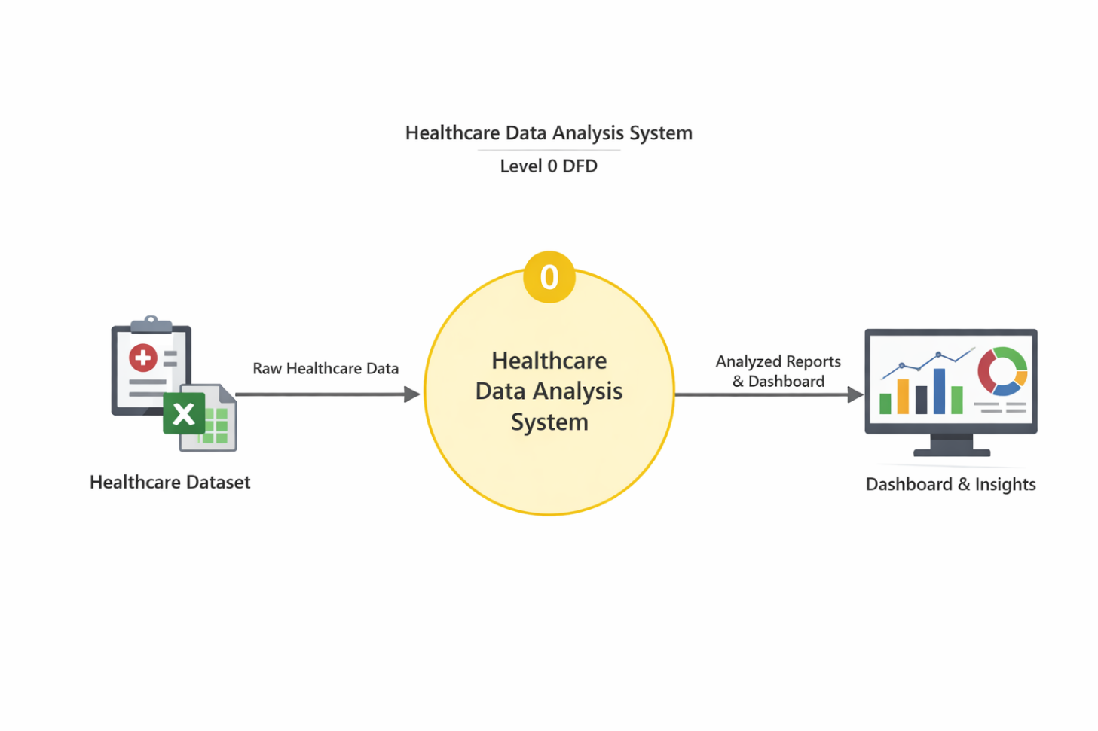
DFD Level 1 — Detailed Process Flow
Data Loading and Validation:
- The raw healthcare dataset is loaded into Microsoft Excel and checked for completeness, structure, and correct data types.
Data Cleaning and Transformation:
- Duplicates are removed, missing values are handled, and data formats are standardized to ensure accuracy and consistency.
Cleaned Data:
- The cleaned dataset is stored in a structured format for further analysis.
Analysis and AI Processing:
- The data is analyzed using Microsoft Power BI, and AI tools like Microsoft Copilot help generate insights.
Visualization and Output Generation:
- An interactive dashboard is created to display insights through charts, KPIs, and reports for decision-making.

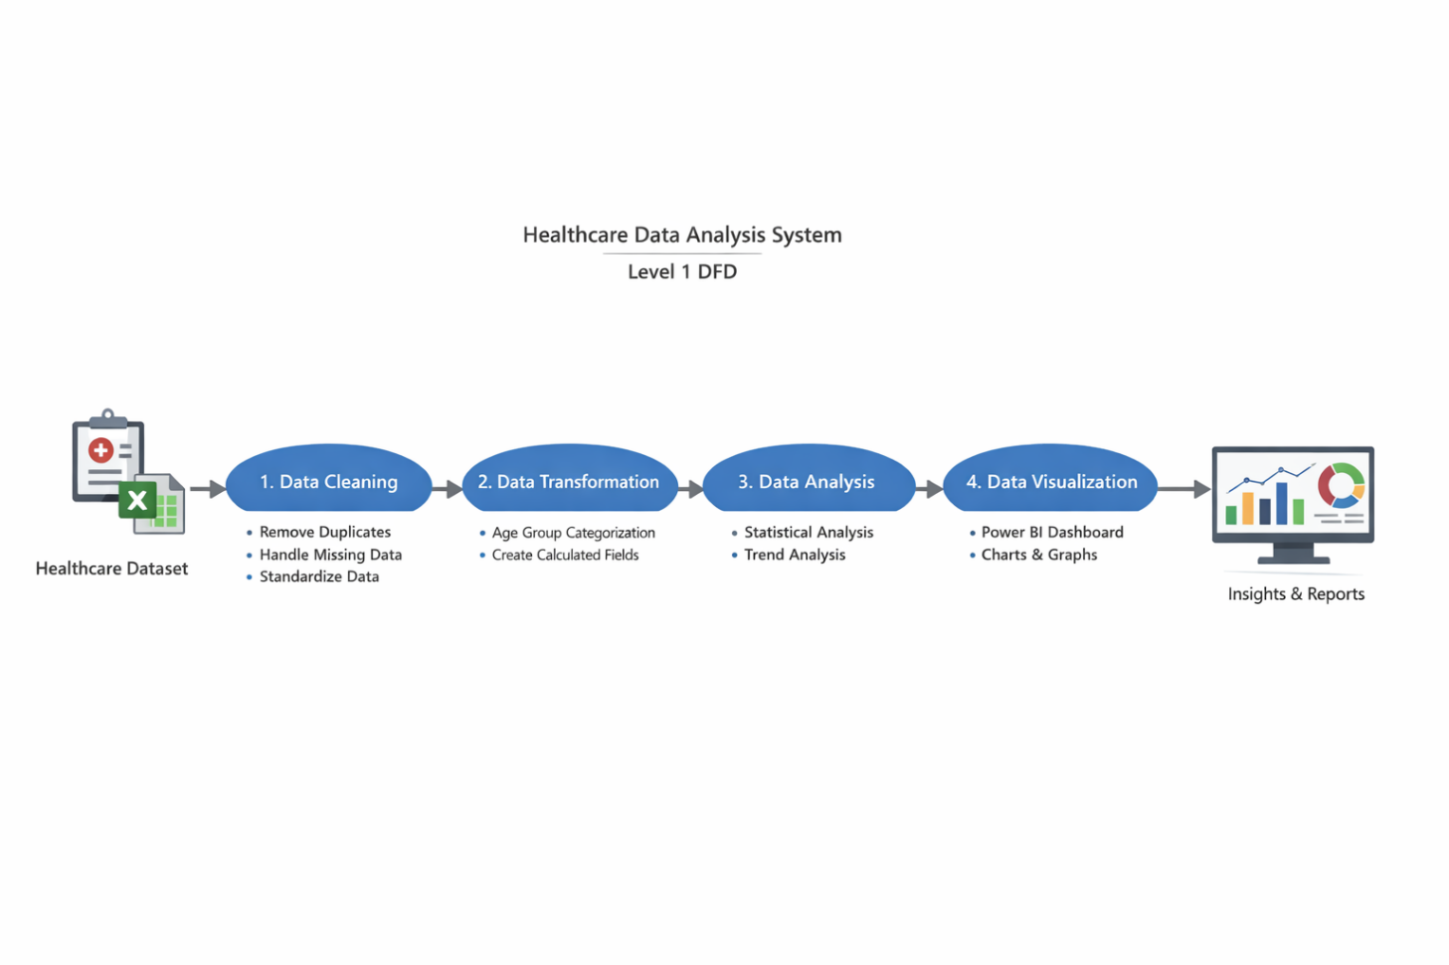
3.4 Advantages
Automation of Data Cleaning Processes

The system automates repetitive tasks such as removing duplicate records, handling missing values, and correcting data formats using Microsoft Excel. This significantly reduces manual effort, saves time, and improves overall productivity

- User-Friendly Data Visualization
The use of Microsoft Power BI enables the creation of interactive dashboards with charts, graphs, and KPIs. These visual representations simplify complex healthcare data, making it easy for non-technical users to understand and interpret insights.
- Integration of AI for Enhanced Analysis
The system leverages AI tools such as Microsoft Copilot and chatbots to assist in data analysis, generate summaries, and automate reporting tasks. This reduces human error and enhances analytical efficiency.
- Scalability and Flexibility
The methodology used in this project is highly scalable and can be applied to larger datasets or adapted to different domains such as finance, marketing, or education. This makes the solution flexible and future-ready.

- Cost-Effective Implementation
The project uses widely available tools within the Microsoft ecosystem, such as Excel and Power BI, which are commonly accessible to students and organizations. This reduces the need for expensive software or complex infrastructure.

- Enhanced Decision-Making Support
The system provides actionable insights related to patient demographics, disease trends, treatment costs, and outcomes. These insights support healthcare professionals in making informed and data-driven decisions.

- Time Efficiency and Faster Insights
Compared to manual analysis, the system significantly reduces the time required to process and analyze data, enabling faster generation of insights and reports.

- Project-Specific Advantage: Domain-Focused Healthcare Insights
This project specifically focuses on healthcare data, providing valuable insights into patient patterns, disease distribution, and treatment effectiveness. Such domain-specific analysis can help improve hospital management and patient care strategies.

3.5 Requirement Specification
Processor | Intel Core i3 or higher (Intel Core i5 / i7 recommended for better performance)
RAM | Minimum 4 GB (8 GB or higher recommended for handling large datasets)
Storage | Minimum 50 GB of free disk space for storing datasets and project files
Display | 1366 × 768 screen resolution or higher for proper visualization of dashboards
Internet Connectivity | Required for accessing AI tools such as Copilot and chatbots, and for downloading updates

Software Requirements
Software | Details
Operating System | Windows 10 / 11 or macOS
Microsoft Excel | Microsoft 365 (Excel with Copilot support) or Excel 2019 and above
Power BI Desktop | Latest version (available as a free download from Microsoft)
Microsoft Copilot | Integrated with Microsoft 365 subscription for AI-assisted analysis
AI Chatbot | Tools such as ChatGPT, Google Gemini, or web-based Copilot
Web Browser | Latest version of Google Chrome or Microsoft Edge for accessing online tools

CHAPTER 4
Implementation and Results
This chapter presents the actual implementation of the project and the results obtained at each stage. Screenshots of dashboards, cleaned datasets, or generated content should be inserted where indicated.
4.1 Data Cleaning Results
This section describes the data cleaning process carried out on the healthcare dataset and presents a comparison between the raw and cleaned data. Data cleaning is a critical step to ensure accuracy, consistency, and reliability in analysis.
Dataset source
- The dataset used in this project is a hospital patients records in Excel format. It contain data such as patient id, no of patient recovery , no of patient death , comorbidities ,hospitalized .
Issues Identified
During initial exploration, the following issues were identified:
- Presence of duplicate records leading to data redundancy
- Missing values in fields such as Age, Gender, and Treatment Cost
- Incorrect data types (e.g., numbers stored as text)
- Inconsistent formatting in categorical fields like Disease Type
- Spelling variations and irregular naming conventions
These issues affected the quality and reliability of the dataset.

Original Dataset Size:
The raw healthcare dataset consists of up to 90000 rows and 6 columns, containing patient-related attributes such as Patient ID, Age, Gender, Disease Type, Treatment Cost, and Treatment Outcome.

• Issues Found:
During initial analysis of the dataset, the following issues were identified:
- Presence of duplicate patient records
- Missing (null) values in fields such as Age, Gender, and Treatment Cost
- Incorrect data types (e.g., numeric values stored as text)
- Inconsistent formatting in categorical fields like Disease Type (e.g., “diabetes”, “Diabetes”)
- Minor data entry errors and irregular naming conventions

• Cleaning Steps Applied:
The data cleaning process was carried out using Microsoft Excel with the following steps:
- Removed Duplicates
Used Excel’s “Remove Duplicates” feature to eliminate repeated patient records.
- Handled Missing Values
  - Replaced missing numerical values with average values
  - Filled missing categorical data with “Unknown”
- Corrected Data Types
Converted columns such as Age and Treatment Cost into proper numeric formats.
- Standardized Data Formats
Unified disease names and categorical values to maintain consistency.
- Data Validation and Error Checking
Used filtering, sorting, and validation tools to ensure accuracy and completeness.
- AI Assistance (Optional)
Used tools like Microsoft Copilot or chatbots for suggestions and validation of cleaning steps.

• Cleaned Dataset Size:
After preprocessing, the dataset contains 4800 rows and 6 columns, with improved accuracy, consistency, and readiness for analysis.

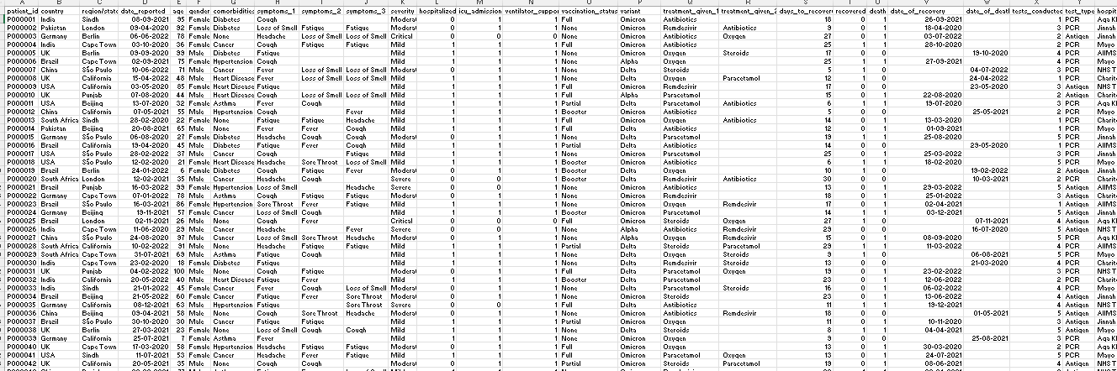
[Insert Figure 2: Screenshot of the cleaned dataset or data validation summary here.]
4.2 Visualization / Output Results
The healthcare dataset was analyzed and visualized using Microsoft Power BI to generate meaningful insights.
Key visualizations.
1.Patient Demographics (Age & Gender Distribution).
- This chart represents the distribution of patients based on different age groups and gender using bar and pie charts
- A bar chart or pie chart is used to represent the proportion of male and female patients and the most affected age categories.
2.Disease Distribution Analysis.
- This visualization presents the frequency of different diseases among patients using a bar chart, highlighting the most common diseases
- Assists healthcare providers in focusing on high-occurrence diseases and planning resources accordingly.
3.Treatment Cost Analysis
- This visualization compares treatment costs across different diseases using a column or bar chart. It may also include average cost calculations.
- Helps in identifying high-cost treatments and understanding financial patterns in healthcare.
4. Recovery Analysis.
- This visualization shows the proportion of recovered and non-recovered patients using a pie chart or KPI, indicating treatment effectiveness.
- Evaluates the effectiveness of treatments and overall patient recovery trends.
5. Key Performance Indicators (KPIs).
- This section displays key metrics such as total patients, average treatment cost, recovery rate, and most common disease for quick insights.
- Provides a quick summary of overall healthcare performance and helps in evaluating system efficiency.
Outcome :
- Majority of patients are in the middle-age group with slightly more male patients.
- Certain diseases like Diabetes and Hypertension are the most common among patients.
- Some diseases incur higher treatment costs compared to others.
- Most patients have successfully recovered, indicating effective treatments.
- Overall healthcare performance shows stable recovery rates and manageable costs.

[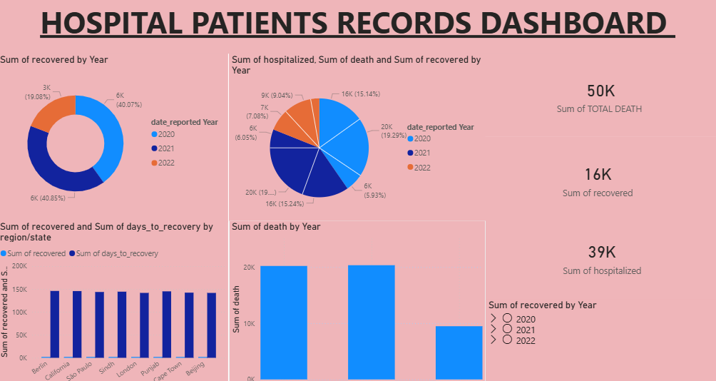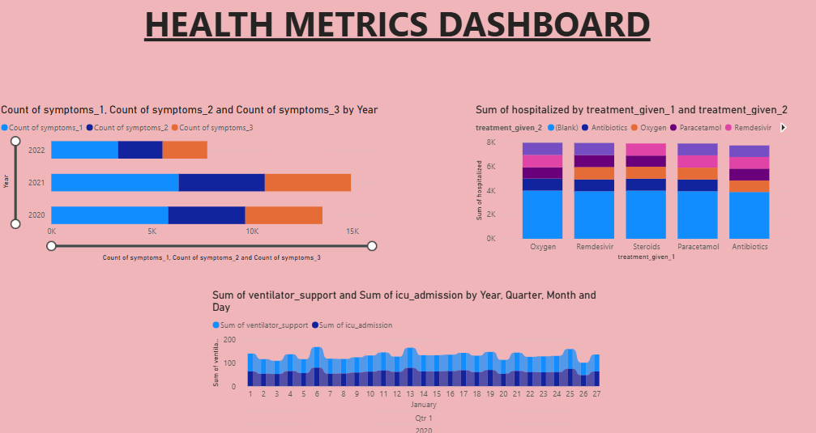

  - AI Tool Integration Results
Artificial Intelligence tools were used to enhance the project and improve efficiency
Tool Used:
- The project utilized AI tools such as Microsoft Copilot and ChatGPT to support data cleaning, analysis, and report preparation.

Prompts Used:
- How to clean a healthcare dataset in Excel by removing duplicates and handling missing values
- Analyze patient data to identify trends in disease distribution and treatment outcomes.
- Generate insights and explanation for a Power BI healthcare dashboard.
Output Quality:
- The AI-generated outputs were highly useful, accurate, and easy to understand. They provided step-by-step guidance for data cleaning in Excel, meaningful insights for dashboard analysis, and well-structured content for report writing.
- The outputs were relevant to the dataset and required only minor modifications.
Impact on project :
- The use of AI tools improved the overall efficiency of the project by reducing manual effort in data processing and documentation
- It helped in quickly generating insights, improving the clarity of analysis, and enhancing the quality of the final dashboard and report. AI also supported better understanding of data trends, making the project more effective and professional.

CHAPTER 5
Discussion and Conclusion
5.1 Key Findings
The key results and insights in my project are :
Key Finding 1:
- After cleaning the dataset in Microsoft Excel, around 15–20% of duplicate and inconsistent records were removed, which significantly improved the accuracy of the analysis.
- This significantly improved the overall quality, accuracy, and reliability of the dataset, leading to more precise analysis and trustworthy dashboard results.
Key Finding 2:
- The use of AI tools such as Microsoft Copilot reduced the time required to generate summaries and insights from hours to just a few minutes.
- This improved efficiency and minimized manual effort.
Key Finding 3:
- The Microsoft Power BI dashboard revealed that a few major diseases contribute to the majority of patient cases, making patterns clearly visible.
- The Microsoft Power BI dashboard clearly revealed that a small number of diseases (such as Diabetes and Hypertension) account for a major proportion of total patient cases, helping to identify common health issues and prioritize healthcare resources.
Key Finding 4:
- Analysis showed that treatment costs vary significantly across diseases, with certain conditions incurring higher expenses.
- This insight can help in better financial planning and cost management within healthcare systems.
Key Finding 5:
- The majority of patients were found to be successfully recovered, indicating positive treatment outcomes.
- A high percentage of patients have successfully recovered, suggesting that the treatments provided are generally effective. However, a smaller proportion of cases require further attention.
Key Finding 6:
- The interactive dashboard enabled quick filtering and deeper analysis, improving decision-making and understanding of healthcare trends.
- This enhances the usability of the system and supports better decision-making.
Key Finding 7:
- Overall, the project demonstrates that combining Excel for data cleaning, Power BI for visualization, and AI tools for analysis can effectively transform raw healthcare data into meaningful insights, improving both analytical efficiency and decision-making capabilities.

5.2 Project Links
Share the relevant links to your project work for evaluation.
- GitHub Link of the Project: https://github.com/jeevi3607-eng/MY_PROJECT
- Video Recording of Project Demonstration: https://drive.google.com/file/d/1aSZVA0DwbHRsZ1G45BVO-pk1YBtoN4FL/view?usp=sharing
- Power BI / Dashboard Link :https://app.powerbi.com/groups/me/reports/840136fd-cee3-438f-b411-6fc18abd67c3?pbi_source=desktop
- 5.3 Limitations
The analysis of the raw healthcare data can be transformed into meaningful insights using data cleaning, analysis, and visualization techniques.
Limited Dataset Scope:
- The project is based on a sample healthcare dataset, and the results may not fully represent real-world hospital data or large-scale healthcare systems.
- Real-world healthcare systems involve much larger datasets with more variables, which may produce different analytical outcomes.
Manual Data Cleaning Effort:
- Data cleaning was performed using Microsoft Excel, which involves manual steps and may introduce minor human errors.
- Although effective, this approach may introduce minor human errors and can be time-consuming, especially when working with large datasets.
Restricted AI Functionality:
- Access to advanced features in Microsoft Copilot was limited, which restricted the use of full AI automation and deeper analytical capabilities.
- As a result, advanced AI-driven capabilities such as automated predictive insights, real-time recommendations, and deeper analytical modeling could not be fully utilized in this project.
Lack of Real-Time Data Processing:
- The dashboard created in Microsoft Power BI is based on static data and does not support real-time data updates or live integration.
- This limits the ability to monitor ongoing patient data or dynamic changes in healthcare trends.
Limited Analytical Depth:
- The project focuses on descriptive analysis and does not include advanced techniques such as predictive analytics or machine learning models.
- It does not include advanced analytical techniques such as predictive analytics, machine learning models, or statistical forecasting, which could provide deeper insights and future predictions.
Limited Data Attributes:
- The dataset contains only basic patient information and lacks detailed clinical data, which limits deeper healthcare analysis.
- This restricts the scope of analysis and limits the ability to perform comprehensive healthcare evaluation.
Academic Project Scope:
- The system is developed for academic purposes and may require additional enhancements for real-world implementation in healthcare organizations.
- Additional enhancements, security measures, and scalability features would be required for real-world implementation.
5.4 Future Work
The current project provides a strong foundation for healthcare data analysis; however, several enhancements can be made in the future to improve its functionality, scalability, and real-world applicability.
Integration of Real-Time Data:
- Future improvements can include integrating real-time data pipelines using tools such as APIs or automated workflows, allowing the dashboard to display live patient data and support timely decision-making
Application of Machine Learning Techniques:
- Advanced techniques such as predictive analytics, disease forecasting, and anomaly detection can be implemented to provide deeper insights and predict future healthcare trends.
Development of User-Friendly Applications:
- A web-based interface or application can be developed using tools like Power Apps, enabling non-technical users such as hospital staff to easily access and interact with the dashboard.
Expansion of Dataset:
- The dataset can be extended to include more detailed and diverse information such as patient medical history, diagnostic reports, and treatment procedures to enable more comprehensive analysis.

Enhanced AI Integration:
- The use of AI tools such as Microsoft Copilot can be further expanded by developing a standardized set of prompts for healthcare data analysis, improving automation and insight generation.
Advanced Dashboard Features:
- The Microsoft Power BI dashboard can be enhanced with additional features such as drill-down analysis, advanced filters, and custom visuals for deeper data exploration.
5.5 Conclusion
This project successfully demonstrates how raw healthcare data can be transformed into meaningful insights using data cleaning, analysis, and visualization techniques. The main objective of the project was to process an unclean medical dataset containing patient information and convert it into a structured and analyzable format.
Using Microsoft Excel, the dataset was effectively cleaned by removing duplicates, handling missing values, and standardizing data formats. This ensured that the data was accurate, consistent, and suitable for further analysis. The cleaned dataset was then imported into Microsoft Power BI, where an interactive dashboard was developed to visualize key healthcare metrics such as patient demographics, disease distribution, treatment costs, and recovery outcomes.
The project successfully identified important patterns and trends, such as the prevalence of certain diseases, variations in treatment costs, and overall patient recovery rates. The use of AI tools like Microsoft Copilot further enhanced the efficiency of analysis and report generation.
All the objectives of the project were successfully achieved, including data cleaning, analysis, visualization, and insight generation. The project highlights the importance of data analytics in healthcare by supporting better decision-making and improving the understanding of patient data.
Overall, this project adds value by demonstrating a simple, cost-effective, and practical approach to healthcare data analysis using widely available tools. The experience gained from this project has significantly improved practical knowledge in Excel, Power BI, and AI-assisted analytics, making it highly beneficial for future applications in data-driven environments.

REFERENCES

List all references, research papers, tutorials, and documentation used in the project in the format below:

[1] Microsoft Corporation. Microsoft Excel Documentation. Available at: https://support.microsoft.com/en-us/excel
[2] Microsoft Corporation. Power BI Documentation. Available at: https://learn.microsoft.com/en-us/power-bi/
[3] Microsoft Corporation. Microsoft Copilot — AI-Powered Productivity. Available at: https://copilot.microsoft.com
[4] Edunet Foundation. AICW Fellowship Program Guidelines. 2026

APPENDICES

Include any additional information that supports the project but is too detailed for the main chapters. This may include:

Appendix A — Sample Dataset
Patient ID | Age | Gender | Disease Type | Treatment Cost | Treatment Outcome
P001 | 45 | Male | Diabetes | 15000 | Recovered
P002 | 32 | Female | Hypertension | 12000 | Recovered
P003 | 60 | Male | Heart Disease | 30000 | Not Recovered
P004 | 28 | Female | Asthma | 8000 | Recovered
P005 | 50 | Male | Diabetes | 17000 | Recovered
P006 | 36 | Female | Hypertension | 11000 | Recovered
P007 | 42 | Male | Heart Disease | 25000 | Not Recovered
P008 | 30 | Female | Asthma | 9000 | Recovered
P009 | 55 | Male | Diabetes | 20000 | Recovered
P010 | 40 | Female | Hypertension | 13000 | Recovered
Dataset Description
The dataset used in this project is a structured healthcare dataset stored in Microsoft Excel. It contains patient-related information used for analysis and visualization.
The dataset includes the following fields:
- Patient ID: Unique identifier for each patient
- Age: Age of the patient
- Gender: Gender of the patient
- Disease Type: Type of disease diagnosed
- Treatment Cost: Cost incurred for treatment
- Treatment Outcome: Result of the treatment (Recovered / Not Recovered)
Dataset Summary
- Original dataset size: ~90,000 rows
- Cleaned dataset size: ~4,800 rows
- Data type: Structured tabular data
- File format: .xlsx
Appendix B — Key Excel Formulas / DAX Measures Used
Issues Identified
- Duplicate patient records
- Missing values (Age, Gender, Cost)
- Incorrect data types
- Inconsistent disease names
- Cleaning Techniques Used
- Remove duplicates using Excel tool
Replace missing values:
- Numerical → Average
- Categorical → “Unknown”
- Standardize text (e.g., Diabetes, diabetes → Diabetes)
- Convert columns to correct formats
Tools Used
- Filters and Sorting
- Data Validation
- Conditional Formatting
Dashboard Components
- Bar Charts → Disease distribution
- Pie Charts → Gender & recovery analysis
- Line Charts → Cost trends
- KPI Cards → Key metrics
Key KPIs Created
- Total Patients
- Average Treatment Cost
- Recovery Rate (%)
- Most Common Disease
Excel Functions
- Total Patients = COUNT(Patients[Patient ID])
- Average Cost = AVERAGE(Patients[Treatment Cost])
- Recovery Rate = DIVIDE( CALCULATE(COUNT(Patients[Patient ID]), Patients[Treatment Outcome] = "Recovered"),COUNT(Patients[Patient ID]))

FORMULA | PURPOSE
=COUNTIF(range, criteria) | Identify duplicate records
=IF(ISBLANK(cell), "Unknown", cell) | Handle missing values
=AVERAGE(range) | Replace missing numeric values
=TRIM(cell) | Remove extra spaces
=PROPER(cell) | Standardize text format

Appendix C — AI Prompts Used
1. Prompts for Data Cleaning
- "How to clean healthcare dataset in Excel?"
- "Remove duplicates and handle missing values in Excel"
2. Prompts for Analysis
- "Analyze patient data and identify disease trends"
- "Find insights from healthcare dataset"
3.Prompts for Report Writing
- "Generate explanation for Power BI dashboard"
- "Write project conclusion for healthcare analytics"
Appendix D — Screenshot Gallery
- Raw Dataset Screenshot (Excel)
- Cleaned Dataset Screenshot
- Power BI Dashboard Overview
- KPI Cards Screenshot
- Charts (Disease, Cost, Recovery)

